Lab 10A

Activity Solution

Activity 1: Identifying Tiers, Layers, and Systemic Qualities



Activity 1: Identifying Tiers, Layers, and Systemic Qualities

**Self-Check –** Match the layers with their definitions.

✓

**Layer** **Definition**

Application Provides the APIs that application

components implement

Virtual Platform Consists of the operating system

Upper Platform Includes computing components such as

servers, storage, and network devices

Lower Platform Provides a concrete implementation of

components to satisfy the functional

requirements

Hardware Consists of products such as web and

Platform containers and middleware

Answers: Virtual Platform, Lower Platform, Hardware Platform, Application, Upper Platform

**Self-Check –** Match the tiers with their definitions.

✓

**Tier** **Definition**

Client Provides services and entities

Presentation All back-end components, such as a Database

Management System (DBMS) or Enterprise

Information System (EIS)

Business Usually described as “thin”; often is a web

browser.

Integration Provides the Hyper Text Markup Language

(HTML) pages and forms sent to a web browser

and process the user’s requests

Resource Provides components that tie the business tier to

the resource tier

Answers: Business, Resource, Client, Presentation, Integration

Activity 1: Identifying Tiers, Layers, and Systemic Qualities



**Self-Check –** Match the systemic qualities with their definitions.

✓

**Systemic Quality** **Definition**

Developmental Addresses the requisite qualities as the

system evolves

Manifest Addresses the qualities reflected in the

execution of the system

Evolutionary Addresses the requisite qualities in

production

Operational Addresses the requisite qualities during

system development

Answers: Evolutionary, Manifest, Operational, Developmental

Activity 2: Exploring Component Diagrams



Activity 2: Exploring Component Diagrams

**Self-Check –** Write the name of each Component diagram symbol in the

* space next to each symbol.



|  |  |
| --- | --- |
| Symbol | Symbol Name |

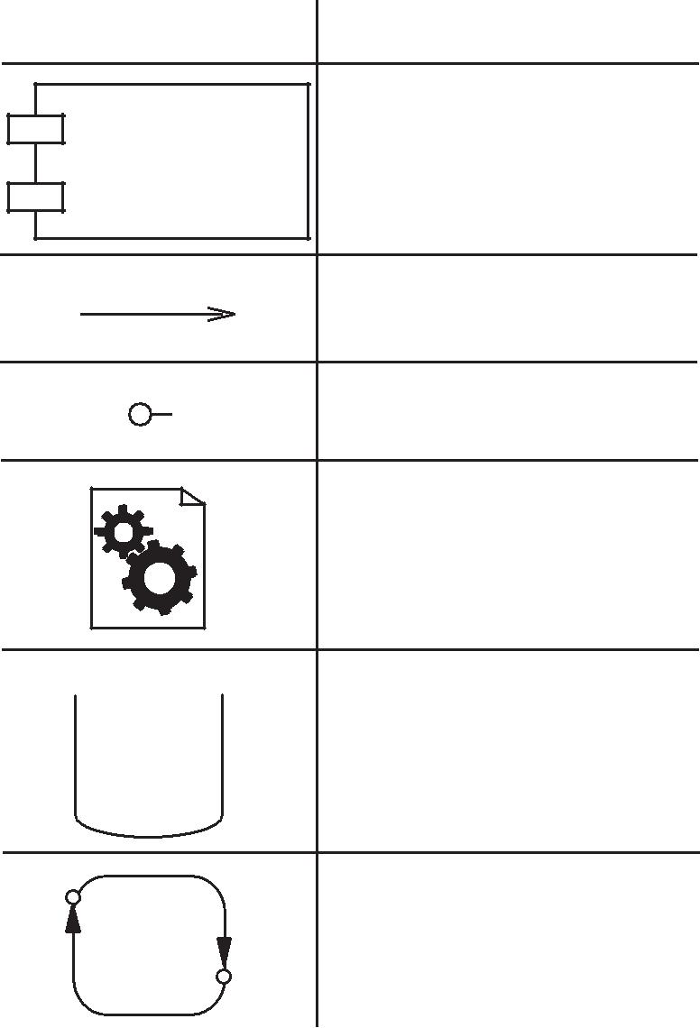

Component node

|  |
| --- |
| Use Only |

|  |  |  |
| --- | --- | --- |
|  | Dependency arrow |  |
|  |  |
|  | Interface icon |  |

Executable file component



DBMS component

Application component



|  |
| --- |
| Oracle Internal & Oracle Academy |

11-4 Object-Oriented Analysis and Design Using UML

Copyright 2010 Sun Microsystems, Inc. All Rights Reserved. Sun Learning Services, Revision E

Page 59 of 83

Activity 2: Exploring Component Diagrams



**Self-Check –** Select the statement or statements about UML Component

* diagrams that are TRUE.



a. ___ A component represents a software unit.

b. ___ There are descriptor and instance forms of

Component diagrams.

c. ___ Components cannot be abstract.

d. ___ Component diagrams show the organizations and

dependencies among components.

e. ___ You can create your own component icons to extend

the UML.

Answers: a, d, and e

|  |
| --- |
| Oracle Internal & Oracle Academy Use Only |

|  |  |
| --- | --- |
| Introducing Architectural Concepts and Diagrams | 11-5 |

Copyright 2010 Sun Microsystems, Inc. All Rights Reserved. Sun Learning Services, Revision E

Page 60 of 83

Activity 3: Understanding Deployment Diagrams



Activity 3: Understanding Deployment Diagrams

**Self-Check –** Write the name of each Deployment diagram symbol in the

* space next to each symbol.



|  |  |  |  |  |  |  |  |  |  |
| --- | --- | --- | --- | --- | --- | --- | --- | --- | --- |
|  |  |  |  |  | Symbol | | Symbol Name |  |  |
|  |  |  |  |  |  |  |  |  |  |
|  |  |  |  |  |  | | Communication link |  |  |
|  |  |  |  |  |  |  |  |
|  |  |  |  |  |  |  |  |  |  |
|  |  |  |  |  |  |  |  |  |  |
|  |  |  |  |  |  |  |  |  |  |
|  |  |  |  |  |  | |  |  |  |
|  |  |  |  |  |  |  | Component node |  |  |
|  |  |  |  |  |  |  |  |  |
|  |  |  |  | | | |  |  |
|  |  |  |  |  |  |
|  |  |  |  |  |  |  |  |  |  |
|  |  |  |  |  |  |  |  |  |  |
|  |  |  |  |  |  |  |  |  |  |

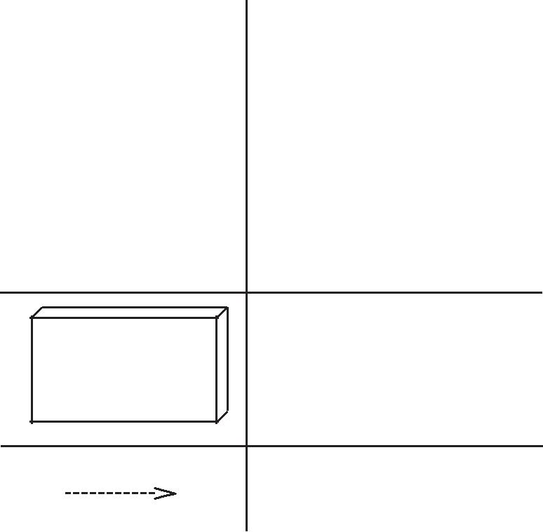

PC

Hardware node

Dependency arrow



|  |
| --- |
| Oracle Internal & Oracle Academy Use Only |

11-6 Object-Oriented Analysis and Design Using UML

Copyright 2010 Sun Microsystems, Inc. All Rights Reserved. Sun Learning Services, Revision E

Page 61 of 83

Activity 3: Understanding Deployment Diagrams



**Self-Check –** Select the statement or statements about UML Deployment

* diagrams that are TRUE.



a. ___ You can assign your own icons to represent

hardware in Deployment diagrams.

b. ___ There are descriptor and instance forms of

Deployment diagrams.

c. ___ Descriptor Deployment diagrams show a particular

deployment of a system.

d. ___ The «deploy» stereotype can be used to document

components within a node.

e. ___ There is only a descriptor form of Deployment

diagrams.

Answers: a, b, and d

|  |
| --- |
| Oracle Internal & Oracle Academy Use Only |

|  |  |
| --- | --- |
| Introducing Architectural Concepts and Diagrams | 11-7 |

Copyright 2010 Sun Microsystems, Inc. All Rights Reserved. Sun Learning Services, Revision E

Page 62 of 83

|  |  |  |  |  |
| --- | --- | --- | --- | --- |
|  | Activity 4: Creating a High-Level Deployment Diagram | | |  |
| **Customer's** | | **Travel Agent System** | **Electronic Payment** |  |
|  |  |
| **Machine** |  | **Travel** | **Machine** |  |
|  |  |  |  |
|  |  | **Agency** | **Electronic** |  |
| **Browser** |  | **Booking** |  |
|  |  | **Software** | **Card Payment** |  |
|  |  |  | **Software** |  |

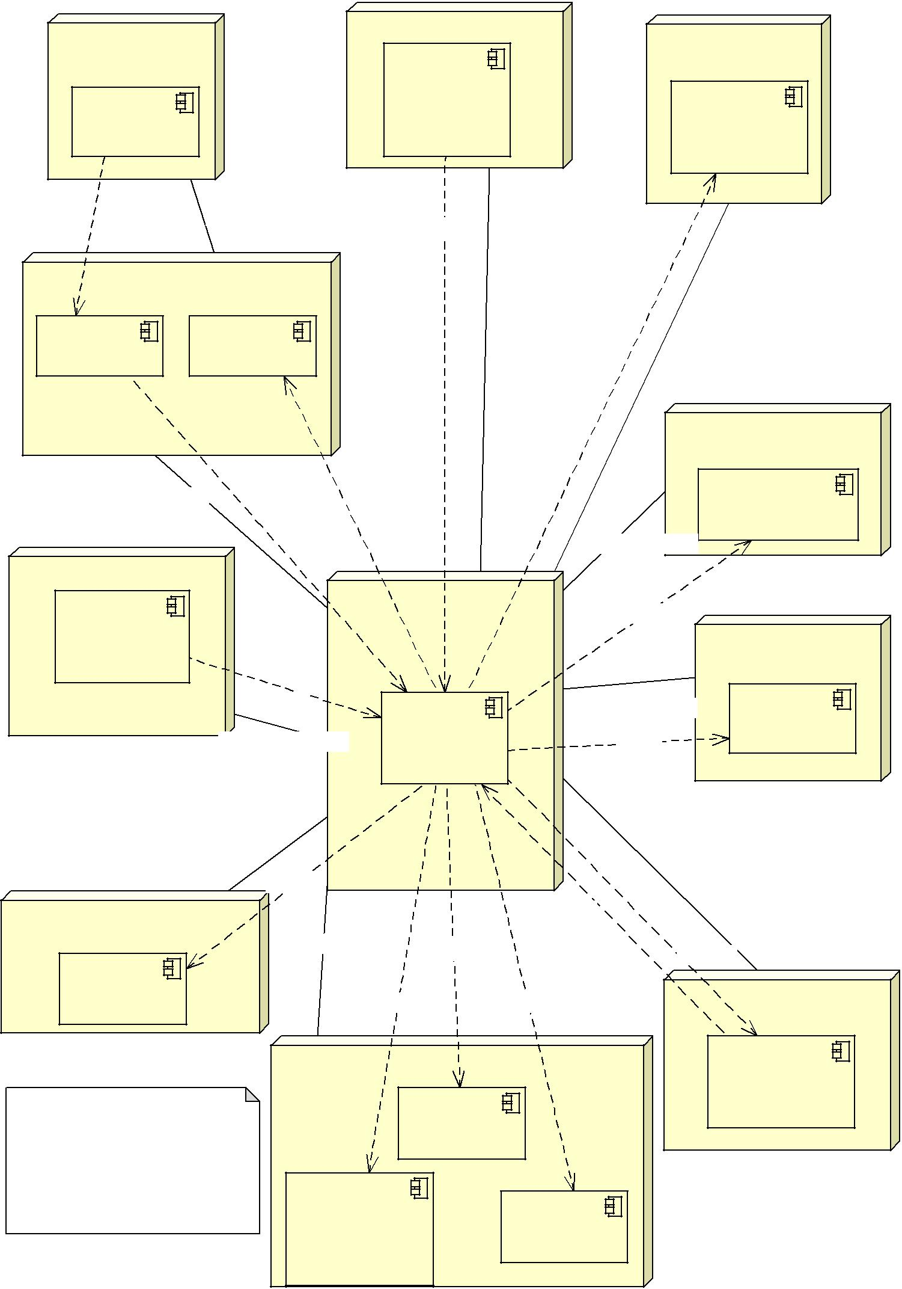

|  |  |  |  |  |
| --- | --- | --- | --- | --- |
| «http(s)» | «tcp/ip/internet» | «soap» | «tcp/ip/internet» |  |
|  |  | «tcp/ip/extranet» |  |
|  |  |  |  |

**Web Interface Machine**

|  |  |
| --- | --- |
| **Web Server** | **Email Client** |

|  |  |
| --- | --- |
| «tcp/ip/intranet» | «rmi» |

«rmi»

|  |  |  |
| --- | --- | --- |
| **Hotel Staff Machines** | **Application Server** |  |
|  |  |
| **Hotel** | **Machine** |  |
|  |  |
| **Interface** |  |  |
| **Software** |  |  |
| «rmi» |  |  |
| «tcp/ip/intranet» | **Hotel** |  |
| **Application** |  |
|  | **Software** |  |

«wifi/IEEE 802.11»

«soap»

«soap»

**External Loyalty Points**

**Scheme Machine**

**Loyalty Points**

**Admin Software**

«tcp/ip/internet»

«soap»

**Database Server**

**Hardware**

|  |  |  |
| --- | --- | --- |
| «tcp/ip/intranet» | **Database** |  |
| «sql» |  |
|  |  |

«wifi/IEEE 802.11»

«device»

**Department Display Screens**

**Display**

**Software**

This is one possible architecture. The distribution of software components and the protocols between the software components may differ in your solution.

|  |  |  |  |
| --- | --- | --- | --- |
|  | «soap» |  |  |
| «tcp/ip/intranet» «soap» |  | «soap» |  |
| «soap» | «soap» | «device» |  |
| **Hand Held Device** |  |
|  |  |  |

|  |  |  |  |
| --- | --- | --- | --- |
| **Hotel Telephone Exchange** | | **Micro Hotel** |  |
|  |  |  |
|  |  | **System** |  |
| **Call Monitor** |  | **Software** |  |
|  |  |  |
| **Software** |  |  |  |
| **Room Phone** | **Text** |  |  |
| **Control** |  |  |
| **Software** | **Software** |  |  |